# VISVESVARAYA TECHNOLOGICAL UNIVERSITY



“JnanaSangama”, Belgavi-590014, Karnataka.

A

Mini Project Report On

### “SUPERMARKET MANAGEMENT SYSTEM”

Submitted in the partial fulfillment of the requirements for the award of the Degree of

### BACHELOR OF ENGINEERING IN

**INFORMATION SCIENCE AND ENGINEERING**

*Submitted by*

**SUMANT HEGDE 1EW18IS100**

**SUNEEL DHARANI 1EW18IS101**

*Under the Guidance of*

##### Ms. Pushpanjali M K

**Assistant Professor, Dept of ISE, EWIT**

**DEPARTMENT OF INFORMATION SCIENCE AND ENGINEERING**

**EAST WEST INSTITUTE OF TECHNOLOGY**

BENGALURU - 560 091

2020-2021

EAST WEST INSTITUTE OF TECHNOLOGY



Sy. No.63,Off.Magadi Road, Vishwaneedam Post, Bengaluru - 560091 (Affiliated To Visvesvaraya Technological University,Belgavi)

### DEPARTMENT OF INFORMATION SCIENCE AND ENGINEERING

**CERTIFICATE**

This is to certify that the mini project work entitled **“SUPERMARKET MANAGEMENT SYSTEM”** presented by **Sumant Hegde (1EW18IS100) And Sunil Dharani (1EW18IS101),** bonafide students of **EAST WEST INSTITUTE OF TECHNOLOGY**, Bengaluru in partial fulfillment for the award of **Bachelor of Engineering** in **Information Science and Engineering** of **Visvesvaraya Technological University**, Belagavi during the year 2020-2021. It is certified that all corrections/suggestions indicated for Internal Assessment have been incorporated in the report deposited in the departmental library. The mini project report has been approved as it satisfies the academic requirements in respect of project work prescribed for the said degree.

------------------------- ------------------------------ -----------------------------

Signature of Guide Signature of HOD Signature of Principal

**Ms. Pushpanjali M K Dr Suresh M B Dr. K Channakeshavalu**

Assistant Professor Prof & Head, Principal

Dept. of ISE Dept. of ISE EWIT, Bangalore

EWIT, Bangalore EWIT, Bangalore

**External Viva**

**Name of the Examiners Signature with date**

**1.**

**2.**

# ABSTRACT

The Project “supermarket” deals with the automation of supermarket. This software will help salespersons in managing the various types of Records pertaining to his/her customer. The product will help the user to work in a highly effective and efficient environment. The salespersons have been recording the customer information in the past and even in the present through their personal manual efforts. And indeed, it consumes their considerable time and energy that could be utilized in the better productive activities. Apart from that, with increasing customer Strength, the task of managing information of each individual customer is indeed a cumbersome task. There is a lot of reason for the introduction of this project. In the manual System, there are number of inefficiencies that a salesperson faces. The information retrieval is one of the foremost problems. It is very difficult to gather the overall performance reports of the customer. Large records-books have to be maintained where relevant and irrelevant information has to be stored which is very untidy and clumsy process. On the other hand, there are many inherent problems that exist in any manual system. Usually, they lack efficiency. Less efficiency has a great impact on the productivity of any human being keeping the data up-to-date. The automation deals with all such problems and tries to remove them in the best suitable fashion. The new system will cater to the need of the salespersons of any supermarket so that they can manage the system efficiently. The project “supermarket” is developed with the objective of making the system reliable, easier, fast, and more informative.

**i**

# ACKNOWLEDGEMENT

Any achievement, be it scholastic or otherwise does not depend solely on the individual efforts but on the guidance, encouragement and cooperation of intellectuals, elders and friends. A number of personalities, in their own capacities have helped us in carrying out this project work. We would like to take this opportunity to thank them all.

First and foremost, we would like to thank **Dr. K Channakeshavalu, Principal, EWIT**, for his moral support towards completing our mini project work.

We would like to thank, **Dr. Suresh M B, Professor and Head of Department of ISE, EWIT**, for his valuable suggestions and expert advice.

We deeply express our sincere gratitude to our guide **Ms. Pushpanjali M, Assistant Professor**, **Department of ISE, EWIT**, for her able guidance throughout the mini project work and guiding us to organize the report in a systematic manner.

We thank our Parents, and all the Faculty members of Department of Information science & Engineering for their constant support and encouragement.

Last, but not the least, we would like to thank our peers and friends who provided us with valuable suggestions to improve our mini project.

##### SUMANT HEGDE 1EW18IS100

**SUNEEL DHARANI 1EW18IS101**

**LIST OF CONTENTS**

**CONTENTS PAGE NO.**

ABSTRACT **i**

ACKNOWLEDGEMENT **ii**

CHAPTER 1: INTRODUCTION 1-2

1.1 Overview 1

1.2 Objective of the project 2

1.3 Advantages 2

1.4 Disadvantages 2

CHAPTER 2: PROPOSED WORK 3-4

2.1 Existing System 3

2.2 Proposed System 3

2.3 Feasibility Study 3

CHAPTER 3: REQUIREMENT SPECIFICATIONS 5-5

3.1 Software requirements 5

3.2 Hardware requirements 5

CHAPTER 4: SYSTEM DESIGN 6-7

4.1 ER Diagram 6

4.2 Schema Diagram 7

CHAPTER 5: IMPLEMENTATION 8-13

5.1 System development life cycle 8-9

5.2 Front end selection 9-12

5.3 Database language selection 13

5.4 Backend language selection 13

CHAPTER 6: TESTING 14-17

6.1 Levels of testing 14-17

CHAPTER 7: SNAPSHOTS 18-23

##### CONCLUSION REFERENCES

**LIST OF TABLES**

|  |  |  |
| --- | --- | --- |
| **Table** | **No Description** | **Page No.** |
| 6.1.1 | Test cases for integration testing | 15 |

6.1.2 Test cases for Input-Output 16

**CHAPTER 1**

**INTRODUCTION**

### Overview

Supermarket management system is the system where all the aspects related to the proper management of supermarkets are done. These aspects involve managing information about the various products, staff, managers, customers, billing etc. This system provides an efficient way of managing the supermarket information. Also allows the customer to purchase and pay for the items purchased.

This project is based on the sales transaction and billing of items in a supermarket. The first activity is based on adding the items to the system along with the rate which are present in the supermarket and the name of the items which the supermarket will agree to sell. This authority is given only to the product manager. Any modifications to be done in the item name and the rate can be done only by him. He also has the right to delete any item. As the customer buys the products and comes to the billing counter, the user is supposed to enter the item name he purchased and the quantity of the item he had purchased.

 Supermarket caters to the needs of the salespersons. It’s easy for the user to meet the challenges of managing their records and retrieval of useful information. The application covers the area of client information, invoice, vendor, product etc and product in hand and delivered information. The system revolves around the menu of the items available. The user can browse through the menu to get the desired information. The project is very flexible because it allows the user to get information in Various possible categories. Everything is done dynamically.

All the details are stored into appropriate database. The functionality of the proposed system includes the following: Customer information Vendor information Product information Quantity in hand Delivered stock, the user can find relevant data in each module itself. He/she can modify, delete, update, view, or inset new data as when required. Performing these tasks is a very simple task in the product and the user can do it quite easily. The database is connected dynamically to front-end so that any changes made to database are immediately reflected to the user.

### Objective of the project

* + - To Manage employees working for a store.
    - Net income and expenditure monitoring.
    - Maintain record of all the products sold in the store.
    - Monitor stock of different products.
    - Add or remove products, remove expired products.
    - To Bill generation.
    - Information can be easily accessed for identification and verification process by the Admin.
* This system will save the time of the Users.

### Advantages

* + - User friendly design.
    - Easy to operate.
    - Has a good user interface.
    - Easy to modify.
    - Expandable.
    - Handle the errors and exceptions satisfactorily.
    - Always a room for scalability.

### Disadvantages

* Error prone: Existing systems are error prone, since manual work is required. More time is consumed and errors may propagate due to human mistakes.
* It needs active internet connection.

**CHAPTER 2**

**PROPOSED WORK**

### Existing System

The existing system is manual /machine systems where the users must have to perform their tasks manually. It will take more time and this whole procedure is very tedious and takes a lot of time.

Problems of the existing system

* + - It is limited to a single system.
    - It has a lot of manual work (Manual work does not mean working with pen or paper, rather includes working on spreadsheets and other simple software.)
    - The present system is very less secure.
    - It is unable to generate different kinds of reports.
    - Retrieval of information is difficult and time consuming.
    - A lot of time and manual effort is required

### Proposed System

Supermarket management system is the system where all the aspects related to the proper management of supermarkets are done. These aspects involve managing information about the various products, staff, managers, customers, billing etc. This system provides an efficient way of managing the supermarket information. Also allows the customer to purchase and pay for the items purchased.

### Feasibility Study

After doing the project Super Market Management System, study and analyzing all the existing or required functionalities of the system, the next task is to do the feasibility study of the project. All the projects are feasible - given unlimited resources and infinite time. Feasibility study includes consideration of the possible ways to provide a solution to the given problem. The proposed solution should satisfy all the user requirements and should be flexible enough so that future changes can be easily done based on the future upcoming requirements.

##### Economic Feasibility

This is a very important aspect to be considered while developing a project. We decided the technology based on minimum possible cost factor.

* + All hardware and software cost has to be borne by the organization. It is limited to a single system. Overall, we have estimated that the benefits the organization is going to receive from the proposed system will surely overcome the initial costs and the later on running cost for system.

##### Technical Feasibility

This included the study of function, performance and constraints that may affect the ability to achieve an acceptable system. For this feasibility study, we studied complete functionality to be provided in the system, as described in the System Requirement Specification (SRS), and checked if everything was possible using different type of frontend and backend platforms.

##### Operational Feasibility

No doubt the proposed system is fully GUI based that is very user friendly and all inputs to be taken all self-explanatory even to a layman. Besides, a proper training has been conducted to let know the essence of the system to the users so that they feel comfortable with the new system. As far our study is concerned the clients are comfortable and happy as the system has cut down their loads and doing.

To ensure success, desired operational outcomes must be imparted during design and development. These include such design-dependent parameters as reliability, maintainability, supportability, usability, producibility, disposability, sustainability, affordability and others. These parameters are required to be considered at the early stages of design if desired operational behaviors are to be realized. A system design and development require appropriate and timely application of engineering and management efforts to meet the previously mentioned parameters. A system may serve its intended purpose most effectively when its technical and operating characteristics are engineered into the design. Therefore, operational feasibility is a critical aspect of systems engineering that needs to be an integral part of the early design phases

**CHAPTER 3**

### REQUIREMENT SPECIFICATIONS

This section describes the software and hardware requirements of the system. Software Requirements Specification (SRS) is a fundamental document, which forms the foundation of the software development process. SRS not only lists the requirements of a system but also has description of its major features. These recommendations extend the IEEE standards. The recommendations would form the basis for providing clear visibility of the product to be developed serving as baseline for execution of a contract between client and the developer.

##### 

##### 3.1 Software requirements

Tools used : Microsoft Visual Studio code Backend Design : Python, JavaScript

Front end design : HTML, CSS, JS

Database : MySQL

##### 3.2 Hardware Requirements

##### 

##### The most common set of requirements defined by any operating system or software application is the physical computer resources, also known as hardware, A hardware requirements list is often accompanied by a hardware compatibility list (HCL), especially in case of operating systems. An HCL lists tested, compatible, and sometimes incompatible hardware devices for a particular operating system or application. The following sub-sections discuss the various aspects of hardware requirements.

Processor : Ryzen 5 3600U, Intel i5

Ram : 8 GB

Hard disk : 500 GB

**CHAPTER – 4**

**SYSTEM DESIGN**

**4.1 DATABASE DESIGN**

* **E-R DIAGRAM OF SUPERMARKET MANAGEMENT SYSTEM**

The entity-relationship model describes inter-related things of interest in a specific domain of knowledge. The figure 4.1 displays the ER diagram of Hospital Management System. An entity-relationship model is composed of entity types and specific relationships that can exist between instances of those entity types.

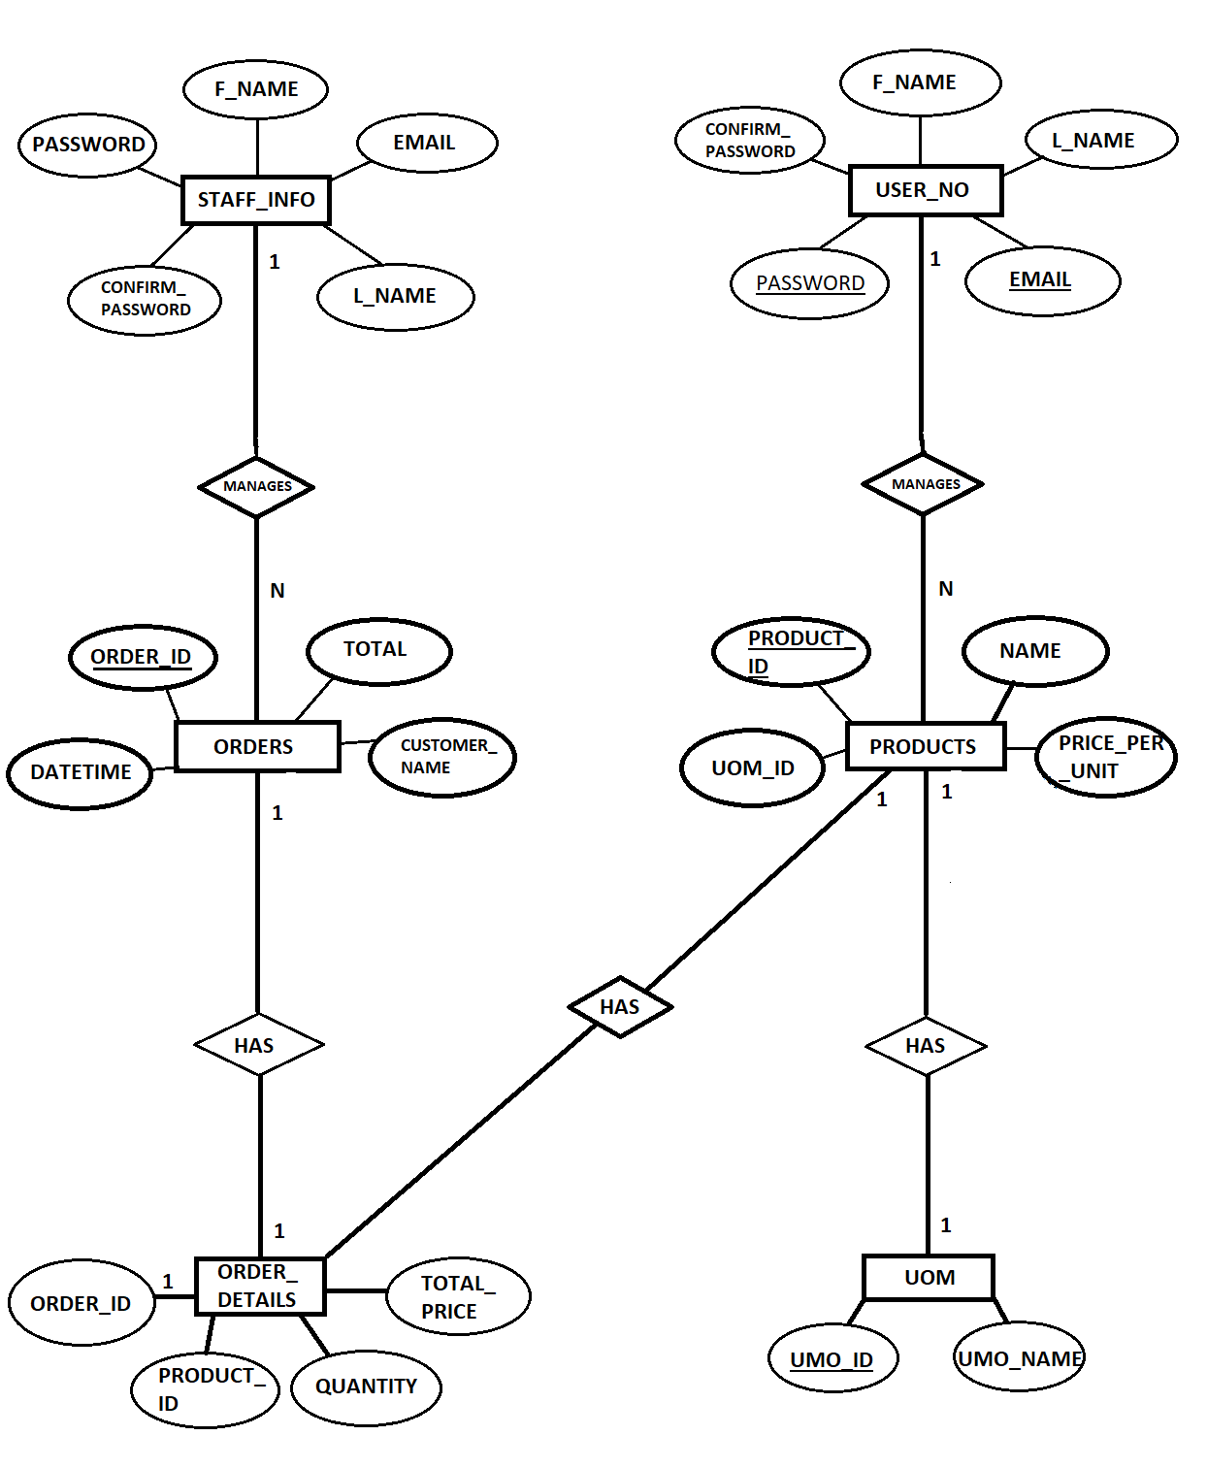

**Figure 4.1: Representing E-R diagram**

* **SCHEMA OF SUPER MARKET MANAGEMENT SYSTEM:**

Schema diagram formulates all the constraints that are to be applied on the data. A database schema defines and the relationship among them. It contains a descriptive detail of the database, which can be depicted by means of schema diagram. A schema diagram is a diagram which contains entities and the attributes that will define that schema. A schema diagram only shows us the database design. Schema can be a single table or it can have more than one table which is related. The schema represents the relation between these tables.

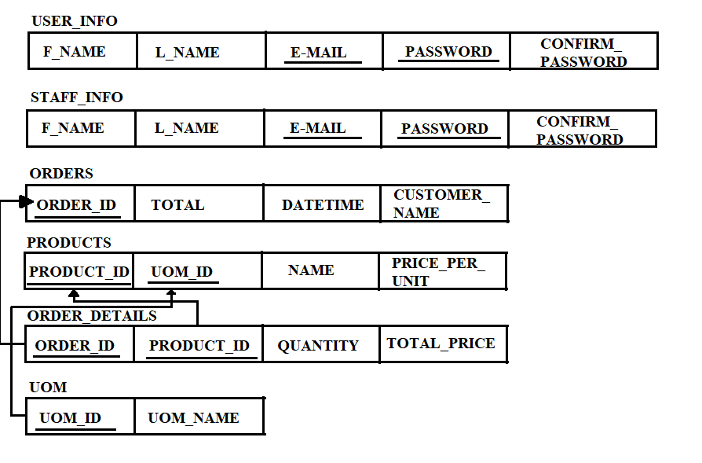

**Figure 4.2: Representing Schema Diagram**

## CHAPTER 5

**IMPLEMENTATION**

Implementation is the phase of the project where detailed design is converted into a working system. Thus, this is the crucial stage in accomplishing successful system which is efficient. Implementation includes methodical planning, examination of constraints, assessment of methods and platform selection. The term implementation has different meanings ranging from the conversation of a basic application to a complete replacement of a computer system. The procedures however, are virtually the same. Implementation includes all those activities that take place to convert from old system to new. The new system may be totally new replacing an existing manual or automated system or it may be major modification to an existing system. Proper implementation is essential to provide a reliable system to meet organization requirement.

### System Development life cycle

Systems Development Life Cycle (SDLC) is the most common process adopted to develop a project and not surprisingly, this project is following this model too. To be precise, a waterfall model is being applied. Waterfall model is a sequential model process where the input of a phase actually results from the previous phase.

There are five phases in this model and the first phase is the planning stage. The planning stage determines the objectives of the project and whether the project should be given the green light to proceed. This is where the proposal submission comes into picture. After obtaining the approval, the next phase is analysis. Gathering and analyzing the system and user requirements is essential for entry to the design step.

With the user requirements gathering completed, there is a need to prepare the resources for the project. Be it software or hardware components, careful consideration and selection is to be taken care at this stage. The decision on the appropriate resources to be used is further elaborated under the subsections below. The next step is to design the system and database structure.

Results from the analysis and preparation that were concluded from the previous stage are put into action. With the user requirements in mind, the flow of the system is planned and the user interface is designed to suit their easy navigation needs. In addition, the number of tables, attributes, primary and unique keys of the database is listed.

After completing the design, actual coding begins. Databases are created and codes are written. Some of the codes required amendments and improvement to it so these are being developed at this fourth stage of the waterfall model. With the development completed, testing will begin. The codes and database are tested to ensure the results obtained are as intended. More time is spent on both development and testing stages because it is inevitable to have errors and issues and buffer time is allocated for troubleshooting.

### Front end selection

##### HTML

Hypertext Markup Language (HTML) is the standard markup language for documents designed to be displayed in a web browser. It can be assisted by technologies such as Cascading Style Sheets (CSS) and scripting languages such as JavaScript.

Web browsers receive HTML documents from a web server or from local storage and render the documents into multimedia web pages. HTML describes the structure of a web page semantically and originally included cues for the appearance of the document. HTML elements are the building blocks of HTML pages.

With HTML constructs, images and other objects such as interactive forms may be embedded into the rendered page. HTML provides a means to create structured documents by denoting structural semantics for text such as headings, paragraphs, lists, links, quotes and other items. HTML elements are delineated by tags, written using angle brackets.

Tags such as <img /> and <input /> directly introduce content into the page. Other tags such as <p> surround and provide information about document text and may include other tags as sub-elements. Browsers do not display the HTML tags, but use them to interpret the content of the page.

HTML can embed programs written in a scripting language such as JavaScript, which affects the behavior and content of web pages. Inclusion of CSS defines the look and layout of content. The World Wide Web Consortium (W3C), former maintainer of the HTML and current maintainer of the CSS standards, has encouraged the use of CSS over explicit presentational HTML since 1997.

HTML documents imply a structure of nested HTML elements. These are indicated in the document by HTML *tags*, enclosed in angle brackets thus:

In the simple, general case, the extent of an element is indicated by a pair of tags: a "start tag" <**p**> and "end tag" </**p**>. The text content of the element, if any, is placed between these tags.

HTML stands for Hyper Text Markup Language. It is the standard markup language for creating Web pages, this describes the structure of a Web page and consists of a series of elements.

**A Simple HTML Document**

<!DOCTYPE html>

<html>

<head>

<title>Page Title</title>

</head>

<body>

<h1>My First Heading</h1>

<p>My first paragraph</p>

</body>

</html>

**Example Explained**

* + - * + The <!DOCTYPE html> declaration defines that this document is an HTML5 document
        + The <html> element is the root element of an HTML page
        + The <head> element contains meta information about the HTML page
        + The <title> element specifies a title for the HTML page (which is shown in the browser's title bar or in the page's tab)
        + The <body> element defines the document's body, and is a container for all the visible contents, such as headings, paragraphs, images, hyperlinks, tables, lists, etc.
        + The <h1> element defines a large heading
        + The <p> element defines a paragraph

**What is an HTML Element?**

An HTML element is defined by a start tag, some content, and an end tag: <tagname>Content goes here...</tagname>The HTML element is everything from the start tag to the end tag:

* <h1>My First Heading</h1>
* <p>My first paragraph</p>

##### CSS

CSS stands for Cascading Style Sheets. It describes how HTML elements are to be displayed on screen, paper, or in other media. CSS saves a lot of work. It can control the layout of multiple web pages all at once. External stylesheets are stored in CSS files. Cascading Style Sheets (CSS) is a style sheet language used for describing the presentation of a document written in a markup

language like HTML.CSS is a cornerstone technology of the World Wide Web, alongside HTML and JavaScript.CSS is designed to enable the separation of presentation and content, including layout, colors, and fonts. This separation can improve content accessibility, provide more flexibility and control in the specification of presentation characteristics, enable multiple web pages to share formatting by specifying the relevant CSS in a separate .css file, and reduce complexity and repetition in the structural content.

CSS information can be provided from various sources. These sources can be the web browser, the user and the author. The information from the author can be further classified into inline, media type, importance, selector specificity, rule order, inheritance and property definition. CSS style information can be in a separate document or it can be embedded into an HTML document. Multiple style sheets can be imported. Different styles can be applied depending on the output device being used; for example, the screen version can be quite different from the printed version, so that authors can tailor the presentation appropriately for each medium.

The style sheet with the highest priority controls the content display. Declarations not set in the highest priority source are passed on to a source of lower priority, such as the user agent style. The process is called cascading. One of the goals of CSS is to allow users greater control over presentation. Someone who finds red italic headings difficult to read may apply a different style sheet. Depending on the browser and the web site, a user may choose from various style sheets provided by the designers, or may remove all added styles and view the site using the browser's default styling, or may override just the red italic heading style without altering other attributes

##### Why Use CSS?

* CSS is used to define styles for your web pages, including the design, layout and variations in display for different devices and screen sizes.

##### Javascript

JavaScript is a high-level, interpreted scripting language that conforms to the ECMAScript specification. JavaScript has curly-bracket syntax, dynamic typing, prototype-based object orientation, and first-class functions. Alongside HTML and CSS, JavaScript is one of the core technologies of the World Wide Web. JavaScript enables interactive web pages and is an essential part of web applications. The vast majority of websites use it, and major web browsers have a dedicated JavaScript engine to execute it. As a multi-paradigm language, JavaScript supports event-driven, functional, and imperative (including object-oriented and prototype based) programming styles. It has APIs for working with text, arrays, dates, regular expressions, and the DOM, but the language itself does not include any I/O, such as networking, storage, or graphics facilities.

It relies upon the host environment in which it is embedded to provide these features. Initially only implemented client-side in web browsers, JavaScript engines are now embedded in many other types of host software, including server-side in web servers and databases, and in non-web programs such as word processors and PDF software, and in runtime environments that make JavaScript available for writing mobile and desktop applications, including desktop widgets. The terms Vanilla JavaScript and Vanilla JS refer to JavaScript not extended by any frameworks or additional libraries. Scripts written in Vanilla JS are plain JavaScript code. Google’s Chrome extensions, Opera's extensions, Apple's Safari 5 extensions, Apple's Dashboard Widgets, Microsoft's Gadgets, Yahoo! Widgets, Google Desktop Gadgets, and Serence Klipfolio are implemented using JavaScript.

##### Advantages of JavaScript

Speed: Client-side JavaScript is very fast because it can be run immediately within the client- side browser. Unless outside resources are required, JavaScript is unhindered by network calls to a backend server.

* + Simplicity: JavaScript is relatively simple to learn and implement.
  + Popularity: JavaScript is used everywhere on the web.
  + Interoperability: JavaScript plays nicely with other languages and can be used in a huge variety of applications.
  + Server Load: Being client-side reduces the demand on the website server.

### Database language selection

* SQL is a standard language for accessing and manipulating databases.
* What is SQL?

SQL stands for Structured Query Language and lets you access and manipulate databases.It became a standard of the American National Standards Institute (ANSI) in 1986, and of the International Organization for Standardization (ISO) in 1987.

* What Can SQL do?

SQL can execute queries against a database and can retrieve data from a database, can insert records in a database, can update records in a database, can delete records from a database, can create new databases, can create new tables in a database, can create stored procedures in a database, can create views in a database, also can set permissions on tables, procedures, and views.

### Backend Language Selection (Python)

Python language is incredibly easy to use and learn for new beginners and newcomers. The

python language is one of the most accessible programming languages available because it has simplified syntax and not complicated, which gives more emphasis on natural language. Due to its ease of learning and usage, python codes can be easily written and executed much faster than other programming languages.

Python was created more than 30 years ago, which is a lot of time for any community of programming language to grow and mature adequately to support developers ranging from beginner to expert levels. There are plenty of documentation, guides and Video Tutorials for Python language are available that learner and developer of any skill level or ages can use and receive the support required to enhance their knowledge in python programming language.

Many students get introduced to computer science only through Python language, which is the same language used for in-depth research projects.

If any programming language lacks developer support or documentation, then they don’t grow much. But python has no such kind of problems because it has been here for a very long time. The python developer community is one of the most incredibly active programming language communities. This means that if somebody has an issue with python language, they can get instant support from developers of all levels ranging from beginner to expert in the community. Getting help on time plays a vital role in the development of the project, which otherwise might cause delays.

## CHAPTER 6

**TESTING**

The testing phase is an important part of software development. It is the processes of finding errors and missing operations and also complete verifications to determine whether the objectives are requirements are satisfied. Software testing is carried out in three steps.

The first step includes unit testing where in each module is tested to provide its correctness, to determine any missing operations and to verify whether the objectives have been met. Errors are noted down and corrected immediately. Unit testing is the important and major part of the project. So, errors are rectified easily in particular modules and program quality is increased. In this project, entire system is divided into several modules.

Second step include integration testing. If we need not be the case that software whose modules when run individually and showing perfect result with also show perfect result as whole. The individual modules are clipped under this major module and tested again and verified the results. A module can have inadvertent, adverse effect on any other on the global data structure causing serious problems. Levels in testing:

* Unit testing
* Integration testing
* Validation testing

### 6.1 Levels of Testing

##### Unit Testing

Unit testing is a method by which individual units of source code, sets of one or more computer program modules together with associated control data, usage procedures, and operating procedures, are tested to determine if they are fit for use. Intuitively, one can view a unit as the smallest testable part of an application. In object-oriented programming a unit is often an entire interface, such as a class, but could be an individual method. For unit testing first we adopted the code testing strategy, which examined the logic of program. During the development process itself all the syntax errors etc. got rooted out. For this developed test case that result in executing every instruction in the program or module i.e., every path through program was tested. Test cases are data chosen at random to check every possible branch after all the loops.

##### User Input

User will be inputting all the data from using a web browser.

##### Error Handling

In this system, we have tried to handle all the errors that occurred while running the application. the common errors we saw were reading a tuple with an attribute set to null and database connection getting lost. For Testing we used Top-Down design a decomposition process which focuses as the flow of control, at latter strategies concern itself with code production. The first step is to study the overall aspects of the tasks at hand and break it into a number of independent modules. The second step is to break one of these modules further into independent sub modules

##### Integration Testing

Data can be lost across an interface, one module can have an adverse effect on the other sub function, when combined may not produce the desired functions. Integrated testing is the systematic testing to uncover the errors with an interface. This testing is done with simple data and developed system has run successfully with this simple data. The need for integrated system is to find the overall system performance.

##### Steps to perform integration testing:

Step 1: Create a Test Plan

Step 2: Create Test Cases and Test Data

Step 3: Once the components have been integrated execute the test cases Step 4: Fix the bugs if any and re test the code

Step 5: Repeat the test cycle until the components have been successfully integrated

**Table 6.1.1 Test cases for integration testing**

|  |  |
| --- | --- |
| Name of the Test | Integration testing |
| Test plan | To check whether the system works properly when all the modules are integrated. |
| Test Data | Sample credential fill up |

##### System testing

Ultimately, software is included with other system components and the set of system validation and integration tests are performed. System testing is a series of different tests whose main aim is to fully exercise the computer-based system. Although each test has a different role all work should verify that all system elements are properly integrated and formed allocated functions.

**Table 6.1.2 Test cases for Input-Output**

|  |  |
| --- | --- |
| **Name of the Test** | **System Testing** |
| Item being tested | Over all functioning of GUI with all  functions properly linked. |
| Sample Input | Sample text files |
| Expected Output | The admin and user module work as expected |
| Actual Output | Application reacts to user inputs in  expected manner. |
| Remarks | Successful |

##### Validation Testing

At the culmination of black box testing, software is completely assembled is as a package. Interfacing errors have been uncovered and the correct and final series of tests, i.e., validation tests begin. Validation test is defined with a simple definition that validation succeeds when the software function in a manner that can be reasonably accepted by the customer.

The process of evaluating software during the development process or at the end of the development process to determine whether it satisfies specified business requirements. Validation Testing ensures that the product actually meets the client's needs. It can also be defined as to demonstrate that the product fulfils its intended use when deployed on appropriate environment

Software validation checks that the software product satisfies or fits the intended use (high-level checking), i.e., the software meets the user requirements, not as specification artifacts or as needs of those who will operate the software only; but, as the needs of all the stakeholders (such as users, operators, administrators, managers, investors, etc.). There are two ways to perform software validation: internal and external.

##### Output Testing

After performing validation testing, the next step is output testing of the proposed system. Since the system cannot be useful if it does not produce the required output. Asking the user about the format in which the system is required tests the output displayed or generated by the system is required tests the output displayed or generated by the system under consideration. The output format on the screen is found to be corrected as the format was designated in the system has according to the user needs. As for the hard copy the output comes according to the specification requested by the user. The output testing does not result in any correction in the system.

##### Test data and Output:

Taking various kind soft data plays a vital role in system testing. After preparing the test data system under study is tested using the test data. While testing, errors are again uncovered and corrected by using the above steps and corrections are also noted for future use.

##### User acceptance Testing:

User acceptance testing of the system is the key factor for the success of the system. A system under consideration is tested for user acceptance by constantly keeping in touch with the prospective system at the time of development and making change whenever required. This is done with regard to the input screen design and output screen design.

##### GUI Testing:

GUI testing is use to ensure the visual clarity of the system, flexibility of the system, user friendliness of the system. The various components which are to be tested are:

* + - * Relative layout
      * Various Links and Buttons

**GUI Testing** is a software testing type that checks the Graphical User Interface of the Software. The purpose of Graphical User Interface (GUI) Testing is to ensure the functionalities of software application work as per specifications by checking screens and controls like menus, buttons, icons, etc.

## CHAPTER 7

**SNAPSHOTS**

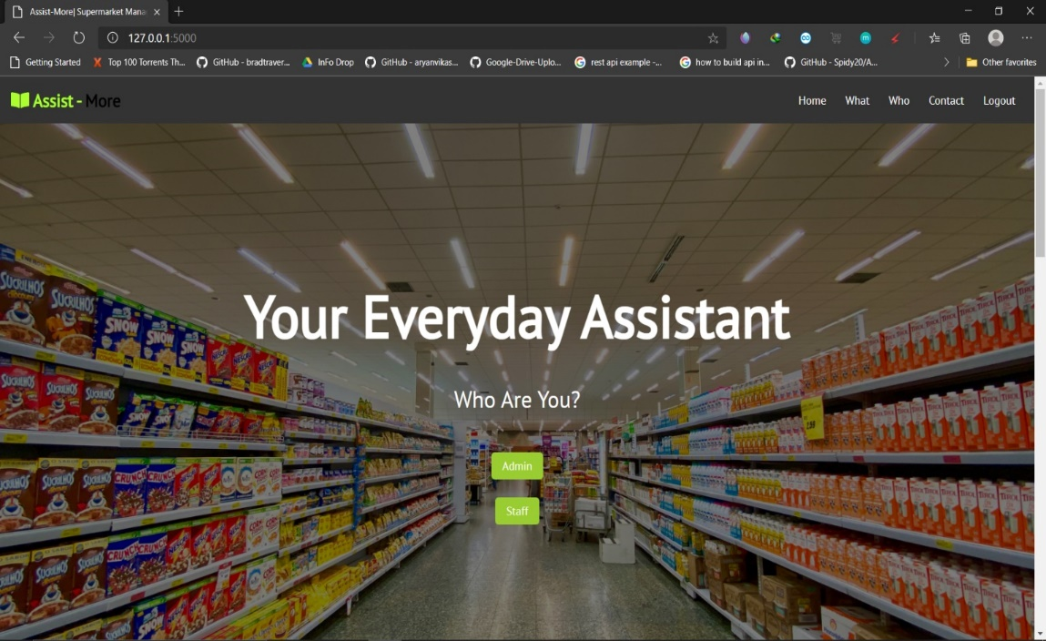

**Figure 7.1: Home Page**

* Above figure shows the home page of Assist-More
* It has Admin Login and Staff login button
* It also has a smooth scrolling Navbar

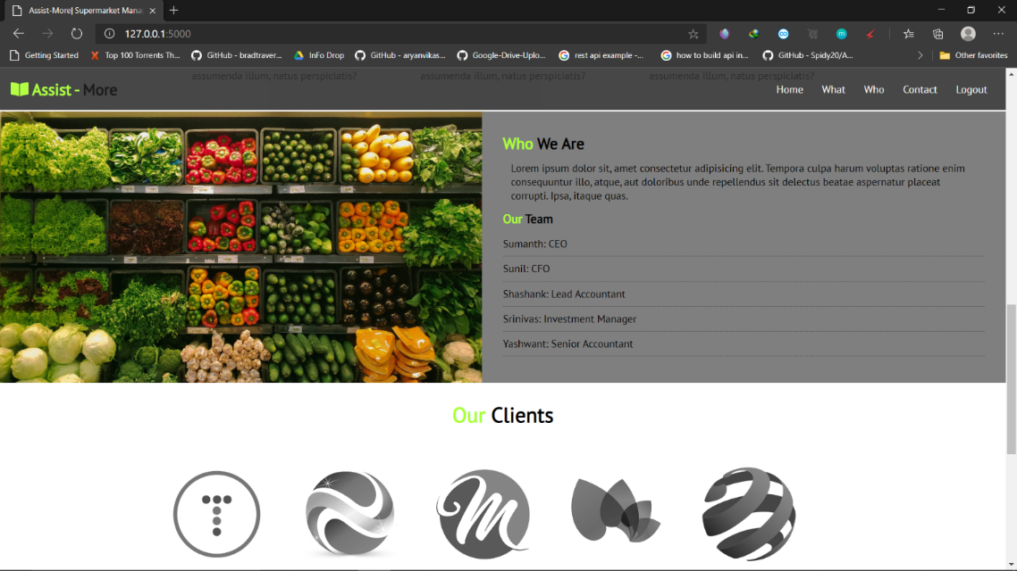

**Figure 7.2: About us and Clients**

* + - Above figure displays info of founders
    - CEO, CFO, Lead Accountant, Managers are mentioned in here

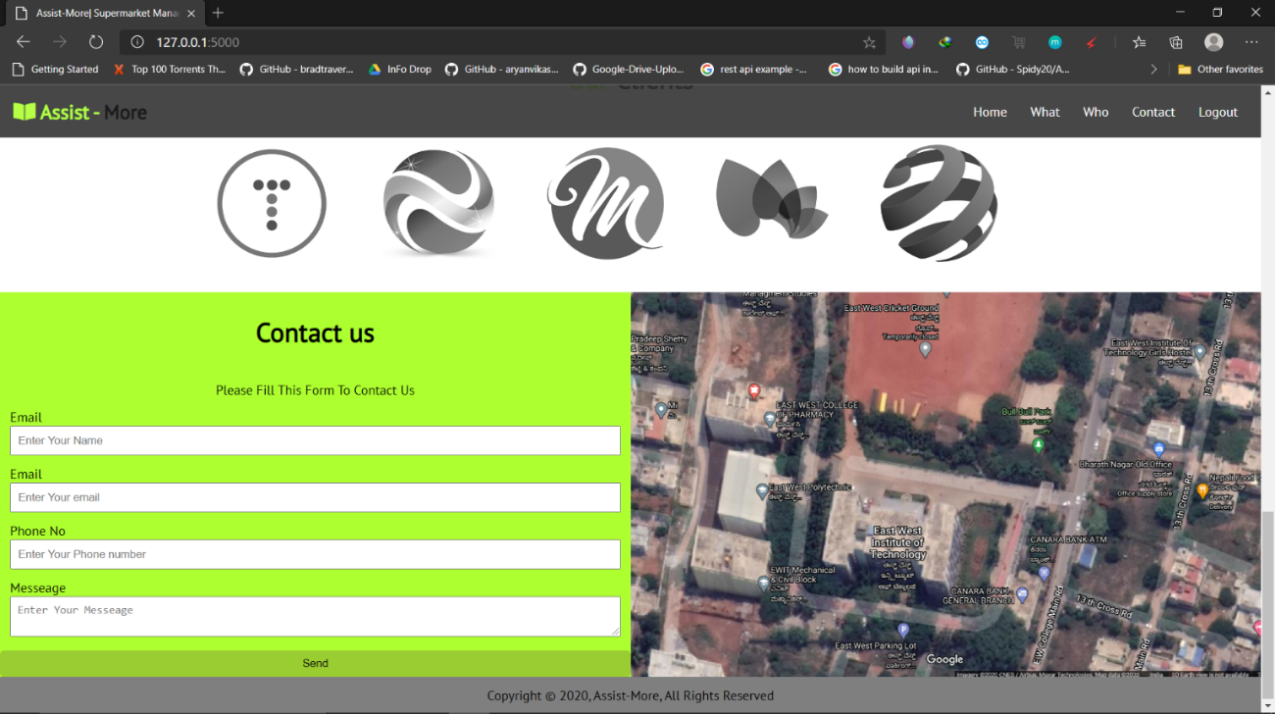

**Figure 7.3: Contact Form & Location**

* This figure contains the location of store
* And also, a contact form to submit queries or feedbacks

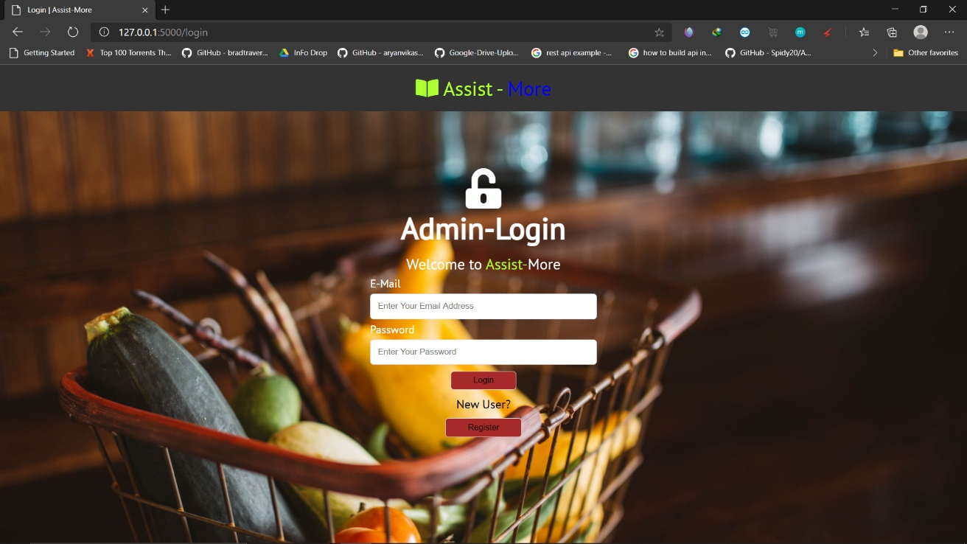

**Figure 7.4: Admin Login**

* The above figure shows the admin login details where the admin can login using

the user name and password.

* If the admin enters incorrect username or password it displays incorrect username

or password.

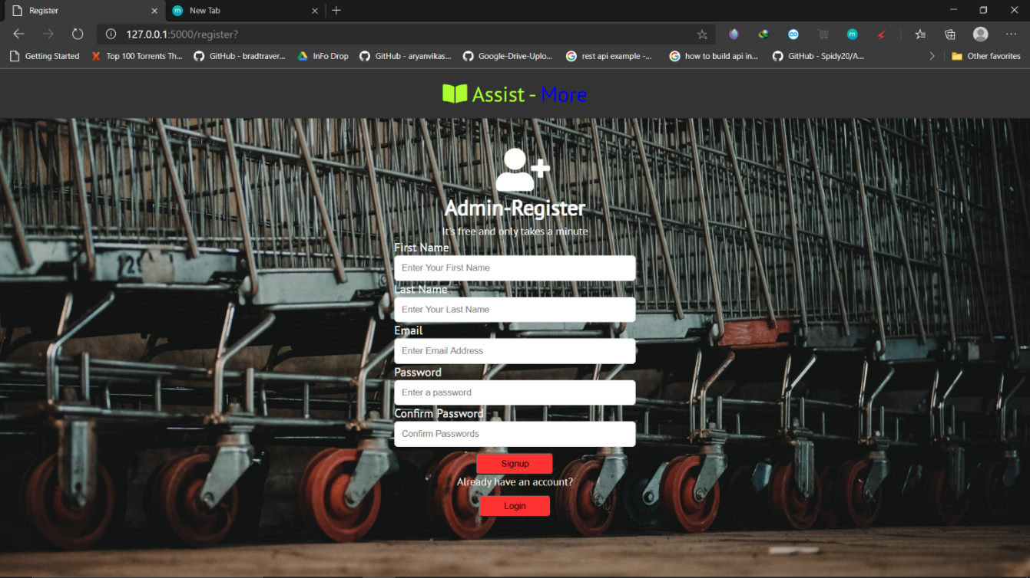

**Figure 7.5: Admin Register**

* This page is used when a new admin has to register his credentials
* Here the admin will fill-out his info and registers himself as admin

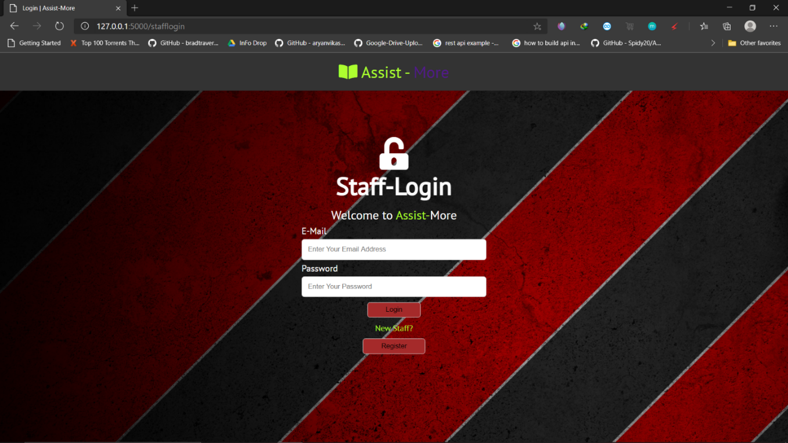

**Figure 7.6: Staff Login**

* The above figure shows the Staff login details where the Staff can login using

the user name and password.

* If the Staff enters incorrect username or password it displays incorrect username

or password.

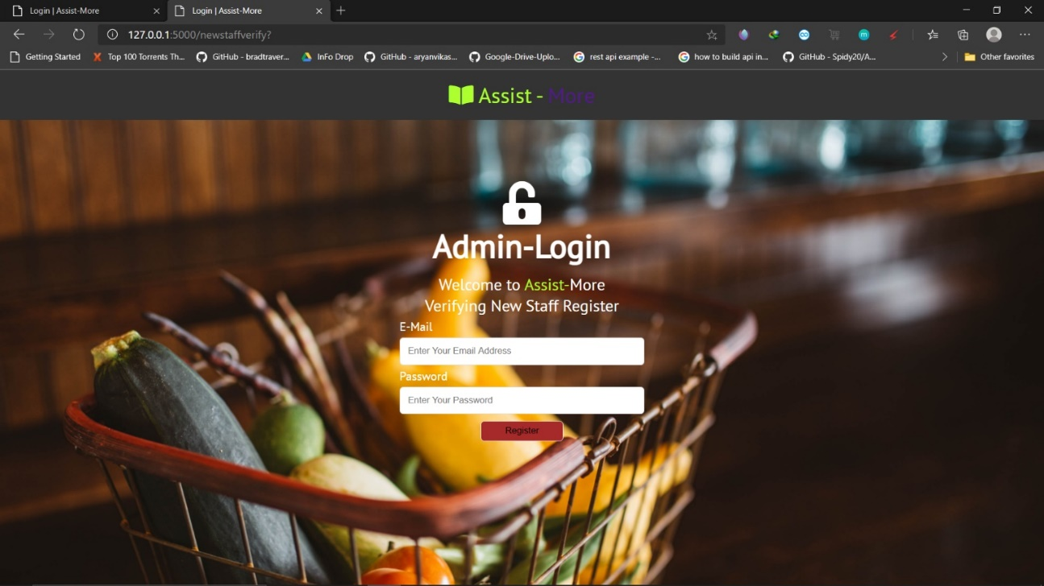

**Figure 7.7: Verifying New Staff Registration**

* This page is used to verify a new Staff when he tried to register himself.
* Admin has to type Super Username and Super Password in order to bypass this

page

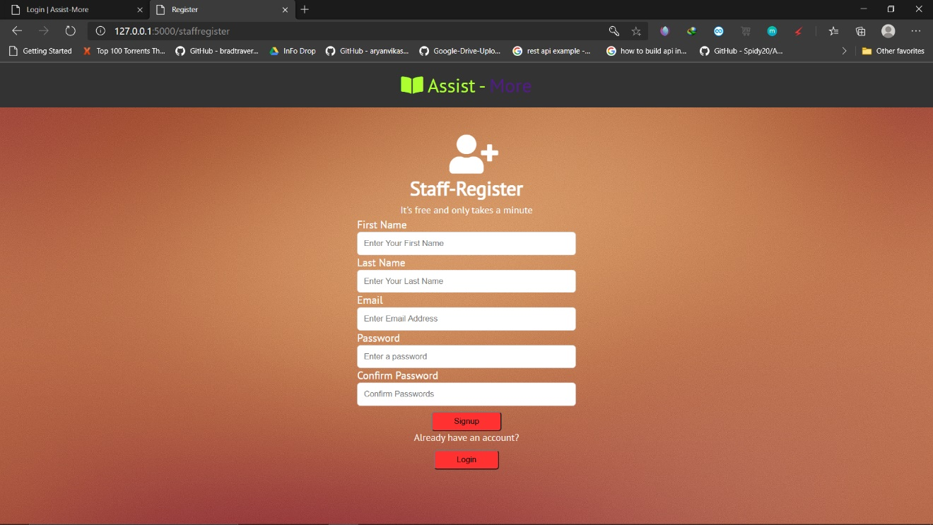

**Figure 7.8: Staff Registration**

* This page is used when a new admin has to register his credentials
* Here the admin will fill-out his info and registers himself as admin

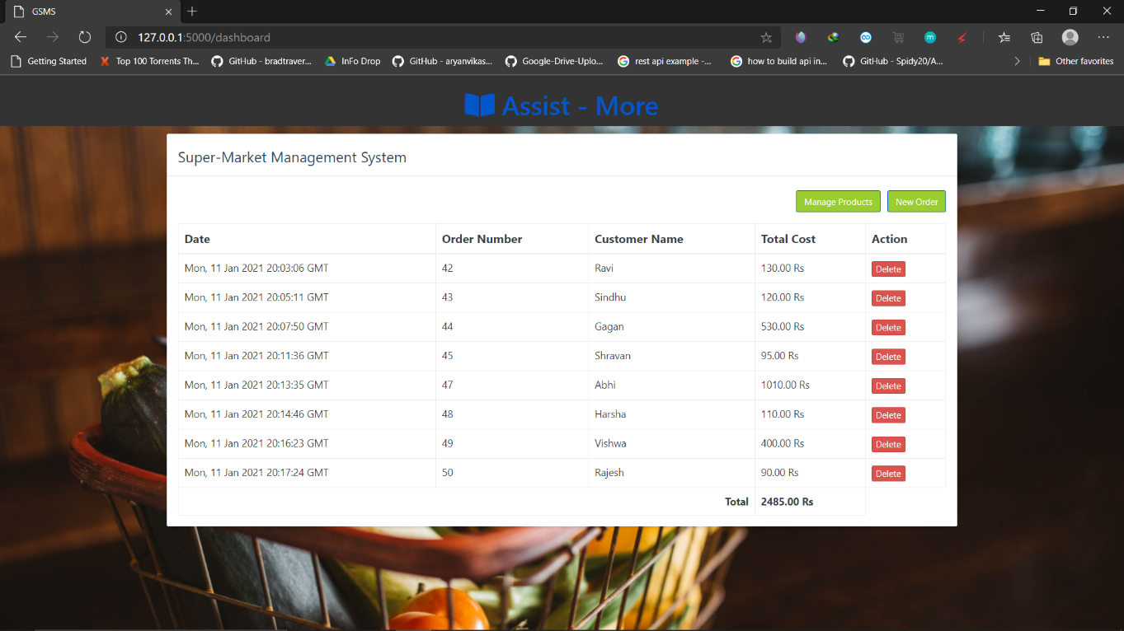

**Figure 7.9: Order Dashboard**

* This is the page we get after logging in, it contains info of all the orders that have been

placed

* The order dashboard has the purchase date & time, Order Number, Customer Name and

Total cost and also a delete button

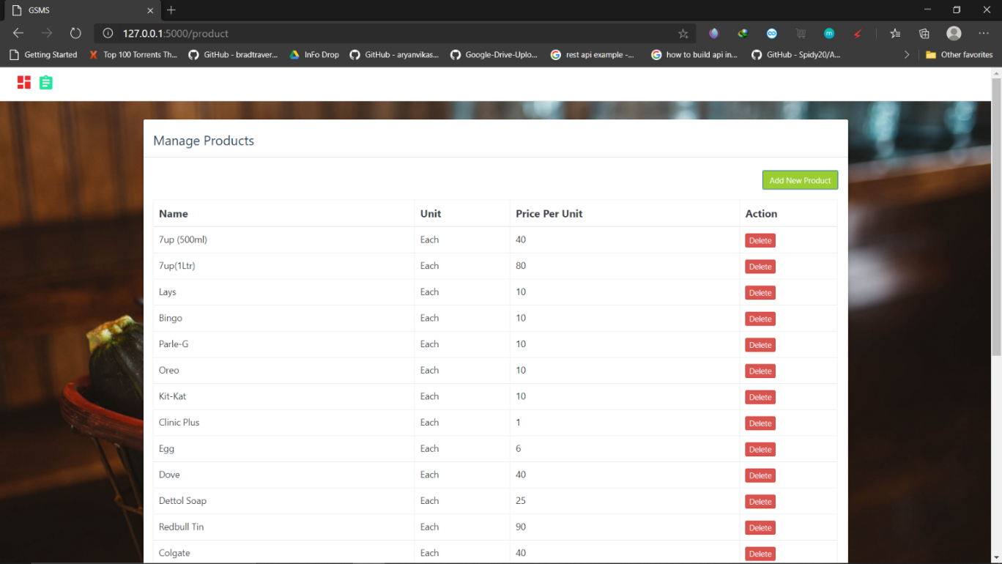

**Figure 7.10: Product Management**

* This page is used by staff or admin to manage the products in the store
* Here one can see the Product name, Unit, Price Per Unit of the product
* He can even delete the product if it goes out of stock
* And can add a New Product

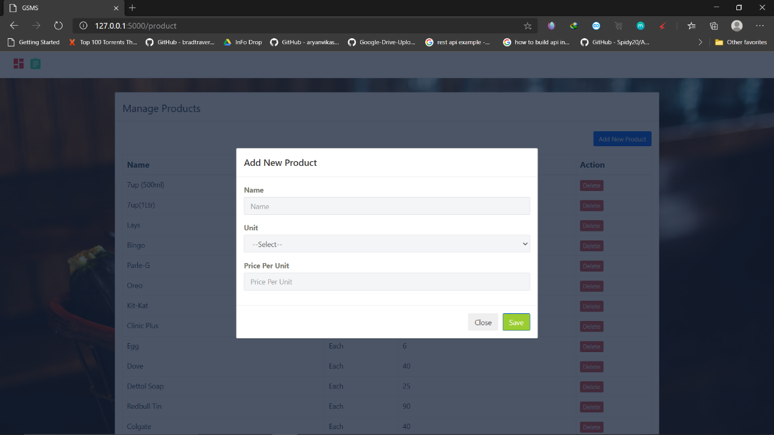

**Figure 7.11: Adding New Product**

* This Figure shows the feature of adding a new product into store
* Admin or Staff can add Product Name, Unit and Price Per Unit of a product

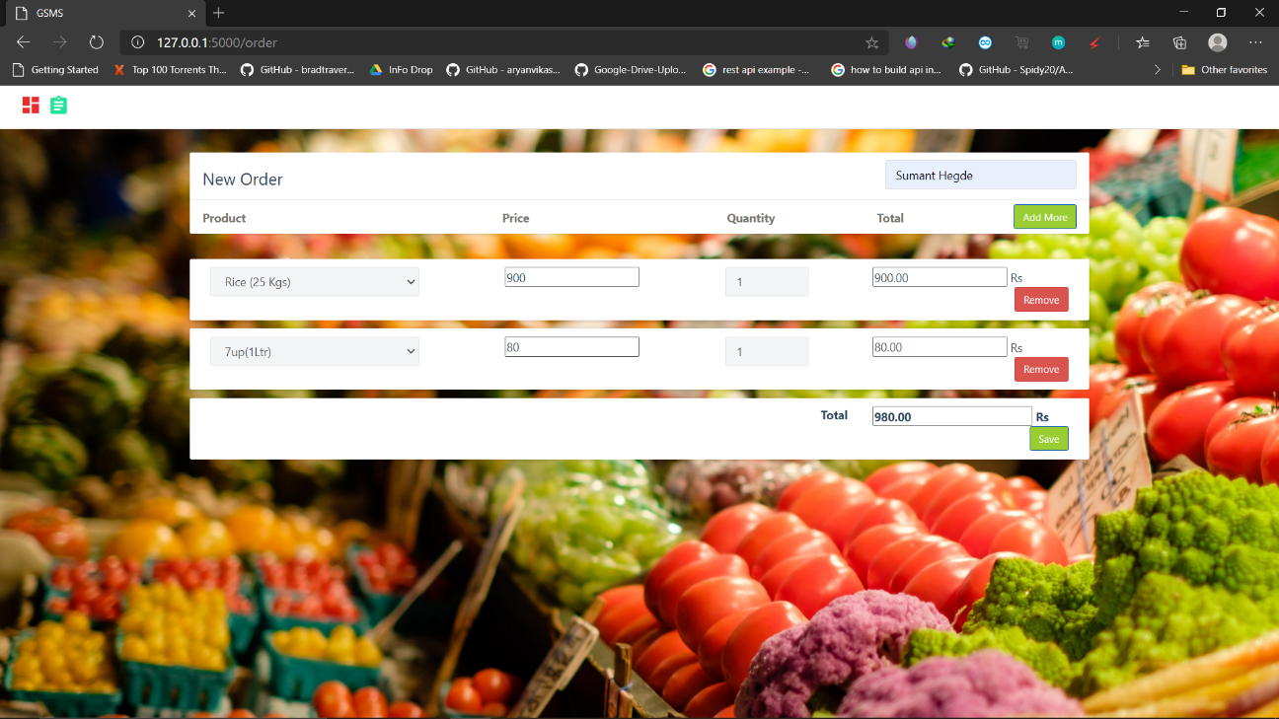

**Figure 7.12: Adding New Order**

* This Figure shows the page of adding a new order of a customer
* Here Staff or Admin has to type Customer Name, Product he purchased, Quantity
* Price will be derived from Product Table and Total will be calculated using JS Code